Home Collection User Manual
Nov 1, 2026 · @purojit
This manual covers the eCare360Plus phlebotomist app, the web screens the lab office uses, and the reports for home collection.

Entire process
A home collection starts on the bill and ends when the lab has the samples and the phlebotomist punches out.
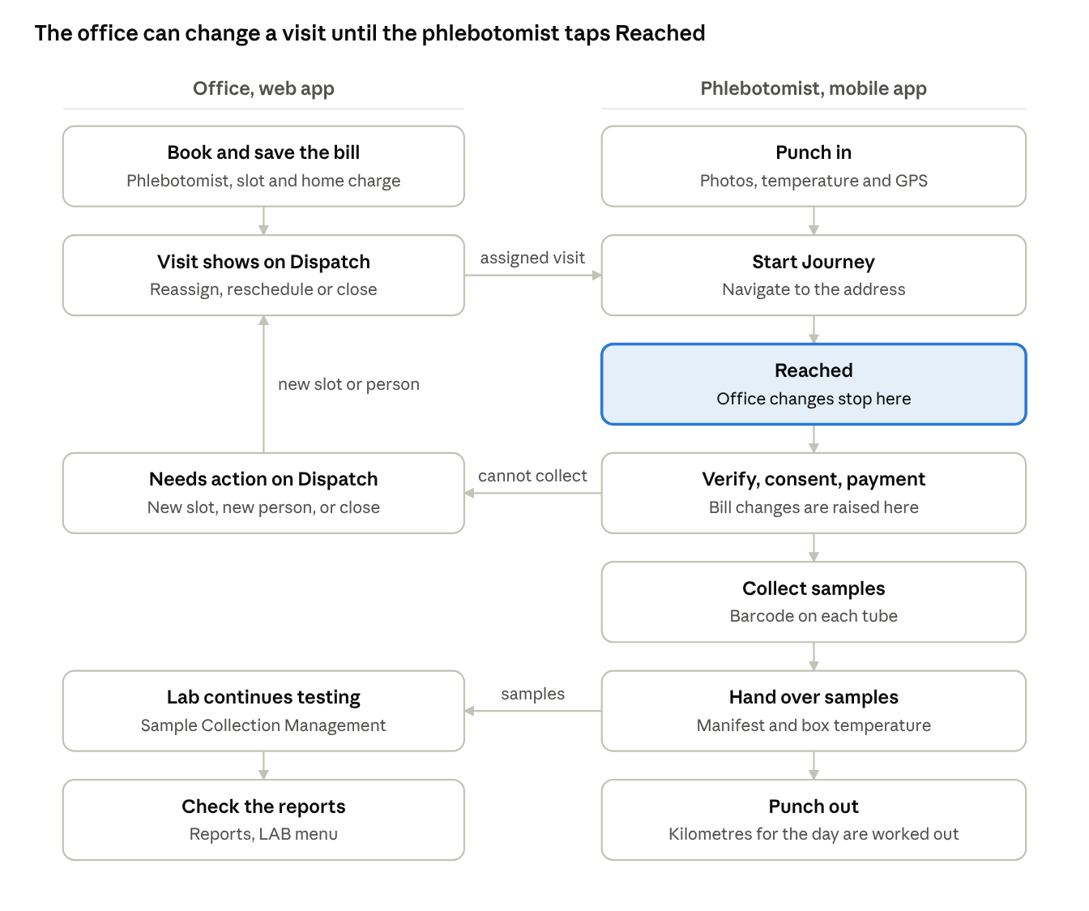
home collection flow · office and phlebotomist
If a tube cannot be taken, the app creates a new visit for the next day, which appears on the Dispatch screen. Cancelling the bill cancels any visit that has not been collected.

Who does what
The front desk books, the dispatcher manages the visit, and the phlebotomist does the field work on the phone.
Role | Works in | Does
Front desk | Web: B2C or B2B booking page | Books the Home Collection, adds the home collection charge, picks the phlebotomist, saves the bill
Dispatcher | Web: LAB > Home Collection Dispatch | Tracks visits, reassigns, reschedules, closes, reopens, and decides bill changes on LAB > Bill Change Approval
Phlebotomist | eCare360Plus app | Punches in, visits the patient, collects samples and payment, hands over samples, punches out
Lab staff | Web: Sample Collection Management and the lab screens | Takes the samples forward for testing
Lab manager | Web: Reports > LAB | Checks pending samples, dues, cash and staff output
Administrator | Web: Users, Shifts, Areas, role permissions | Sets up phlebotomists and gives access to the Dispatch page

Setup before first use
A phlebotomist can use the app only after the user record is complete, so finish these steps once per person.
- Open Settings > User Master in the web app. Tap Add User, or tap the pencil on an existing user.
- On step 4, Clinical & Status, turn on Is Phlebotomist and tap Configure. Enter the Certification No, which is mandatory.
- Choose the Shift and the Assigned Zone. Without them the app shows "Your shift or zone is not set."
- Enter the Daily Collection Target. The app shows progress against it.
- Link the user to the branch where they work.
- Give the office team access to LAB > Home Collection Dispatch and LAB > Bill Change Approval through role permissions. Until then only Super Admin sees it.
- Install the app on the phone. Allow location, camera and notifications when asked.
The first phone a phlebotomist signs in from is approved automatically. Any later phone waits until the office approves it on LAB > Phlebotomist Phones. The app gives each install its own ID, so installing it again, or clearing the app's data, counts as a new phone. Save the latitude and longitude on each branch, otherwise every punch in goes to review.
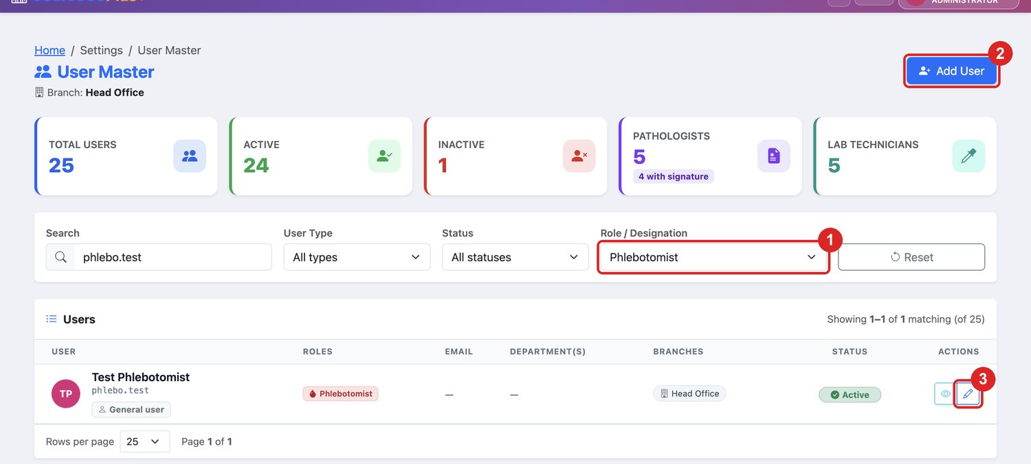
Figure W1. In User Master, (1) set Role / Designation to Phlebotomist to list your phlebotomists, (2) tap Add User for a new person, or (3) tap the pencil to edit one.
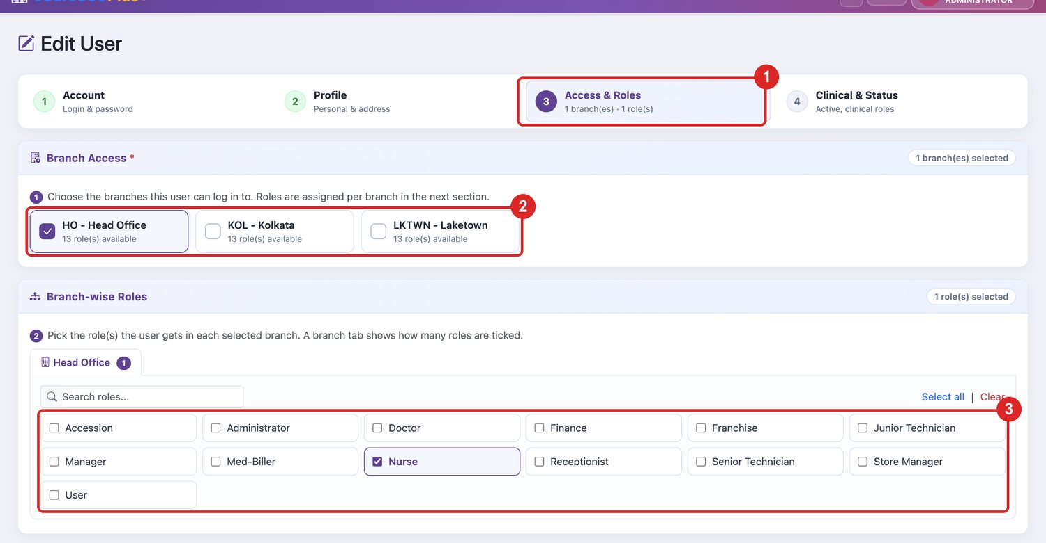
Figure W2. On (1) step 3, Access & Roles, tick (2) the branch where the person works and (3) their role in that branch.
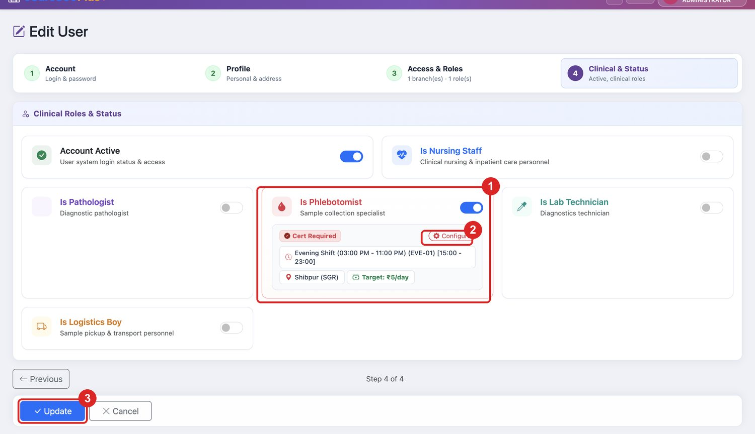
Figure W3. On step 4, (1) turn on Is Phlebotomist, (2) tap Configure and, once the details are entered, (3) tap Update. The Cert Required badge shows that no Certification No is saved yet.
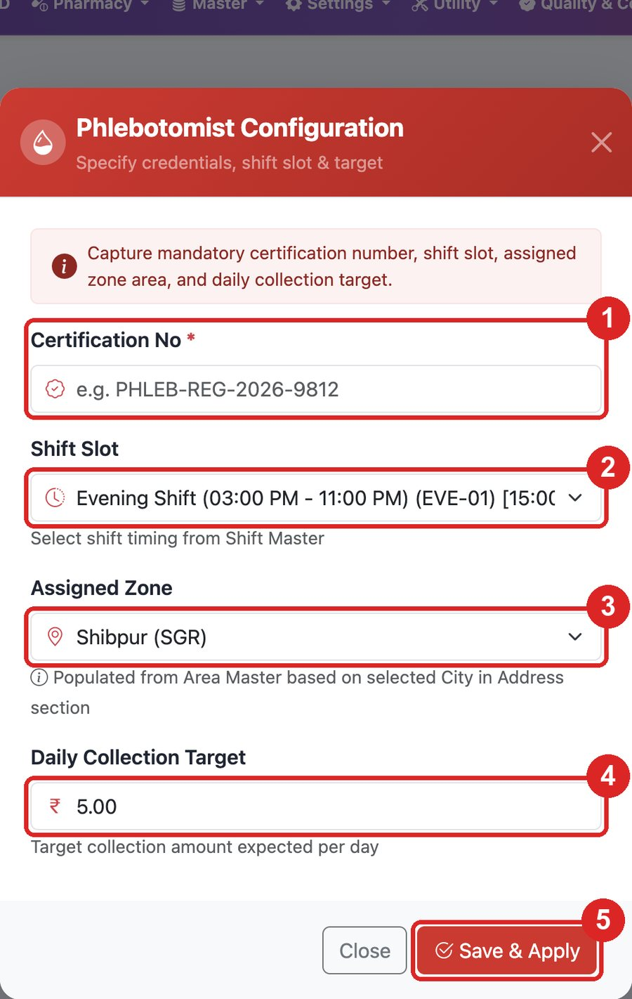
Figure W4. Enter (1) Certification No, (2) Shift Slot, (3) Assigned Zone and (4) Daily Collection Target, then tap (5) Save & Apply. The details are saved only when you tap Update on step 4.

Phlebotomist app
The daily order is fixed: punch in, finish each visit, hand over samples, then punch out.

Log in
- Open the app and tap Phlebotomist login.
- Enter your EMR username and password, then tap Log In.
- If asked, set a new password of at least 8 characters and sign in again.
- If your login works in more than one branch or role, choose the one for today.
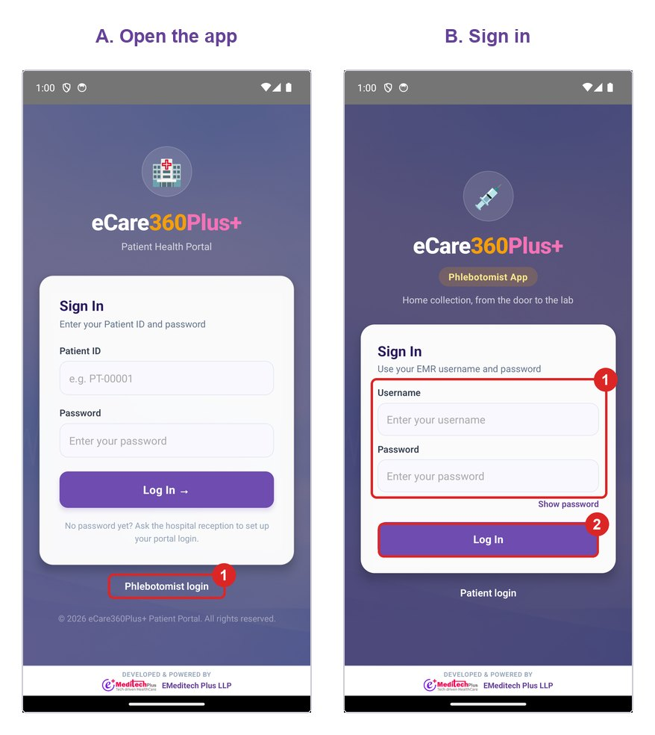
Figure 1. In A, tap (1) Phlebotomist login. In B, enter (1) username and password and tap (2) Log In.

Forgot password
The code goes to the mobile number saved on your user in User Master, so the office must save it first.
- On the sign-in screen, tap Forgot password?.
- Enter your username and tap Send Code.
- Enter the 6-digit code from WhatsApp and tap Verify Code. The code works for 10 minutes.
- Enter the New password and Confirm password, then tap Reset Password.
- Sign in with the new password.
The password needs at least 8 characters, with upper-case and lower-case letters and a digit. Resetting it signs you out of every device.
The app shows the same message whether or not a code was sent, to keep usernames private. If nothing arrives, ask the office to check your mobile number and the branch's WhatsApp setup. A code stops working after five wrong tries. You can ask for one code a minute, up to five an hour.

Punch in
- Stand at your branch or an approved start point, with GPS on.
- In Duty checklist, take the selfie, vehicle, medical bag and temperature gun photos.
- Enter the Temperature reading.
- Tap Punch In. The screen changes to On duty · location recording.
Location is recorded only while you are on duty. If you see "Your punch needs a supervisor's review", continue working and tell your supervisor.
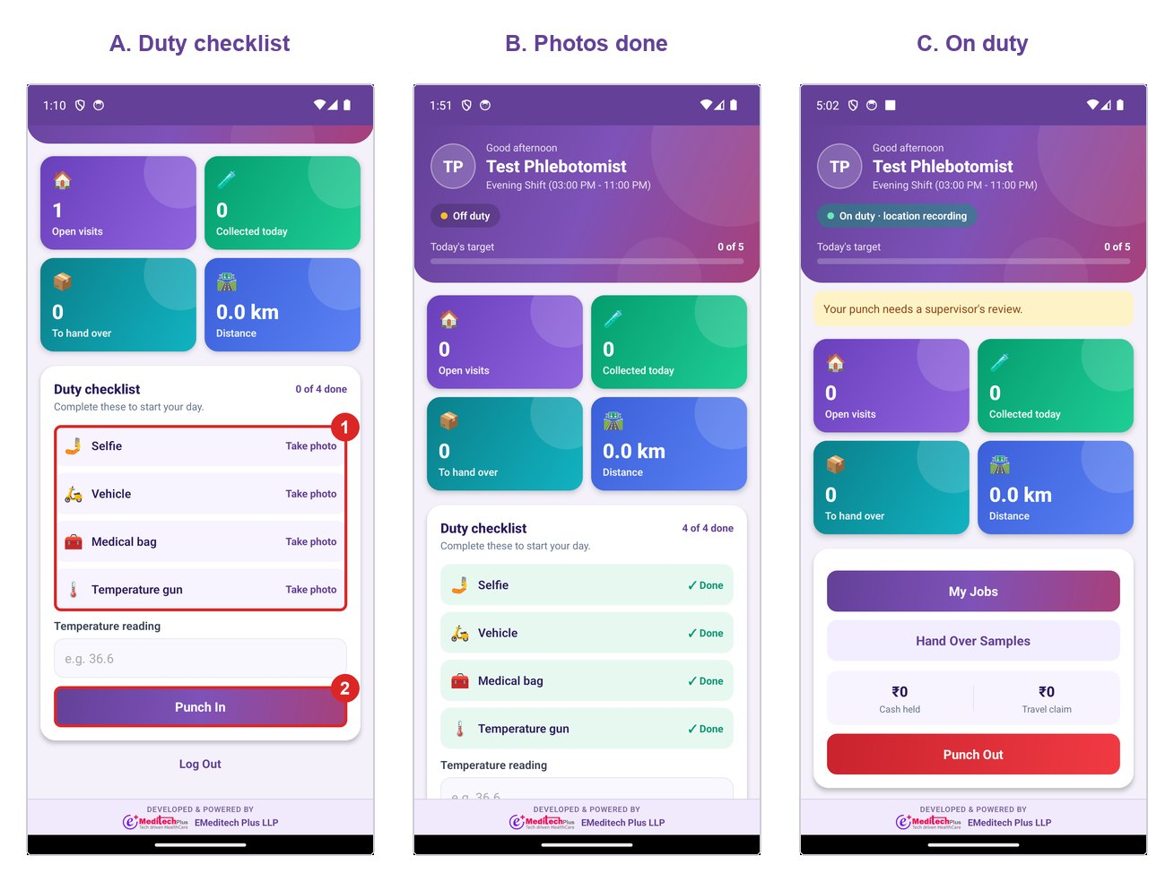
Figure 2. In A, take (1) all four photos and tap (2) Punch In. B shows the checklist complete. C shows the dashboard once you are on duty.

Dashboard
Item | Meaning
Open visits | Visits still to finish. Tap to open My Jobs
Collected today | Visits collected today, also shown against your target
To hand over | Collected visits not yet given to the lab. Tap to open Hand Over Samples
Distance | Payable kilometres for the day
Cash held | Cash you collected and still hold
Travel claim | Travel amount earned today

My Jobs
Tab | Visits shown
Pending | Assigned, not started
Check In | On the way, reached or collecting
Completed | Collected, waiting for handover
Booking Complete | Handed over
Tap a visit to see the patient, slot, bill, address and tests. Use Navigate for the map and Call patient to phone.
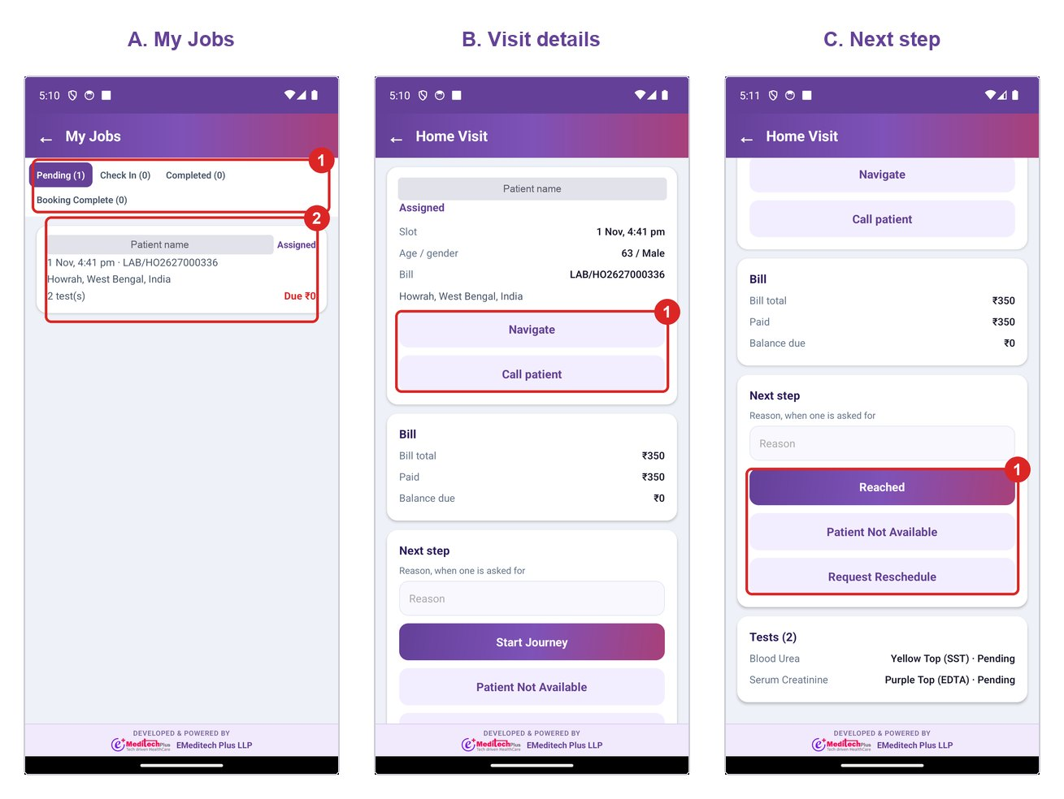
Figure 3. In A, choose (1) a tab and tap (2) a visit. In B, use (1) Navigate or Call patient. In C, (1) the next step changes with the visit, shown here after Start Journey. The patient name is hidden in these pictures.

Do a visit
- Tap Start Journey. You can have only one visit running at a time.
- At the address, tap Reached. If you are over 200 m from the patient's pin, type a reason and tap again.
- Verify the patient. Tap Send code on WhatsApp, enter the 4-digit code, and tap Check code.
- If the code does not arrive, take Photo of patient's ID, type a reason, and tap Verify by ID proof.
- Tap Photo of signed consent. Add Photo of prescription if there is one.
- Tap Begin Collection, then Collect Samples.
- Check the barcode on each tube, or enter or scan it. Tests in the same tube share one barcode.
- If a tube could not be taken, tap Mark as not collected and choose why.
- Tap Save Sample Collected.
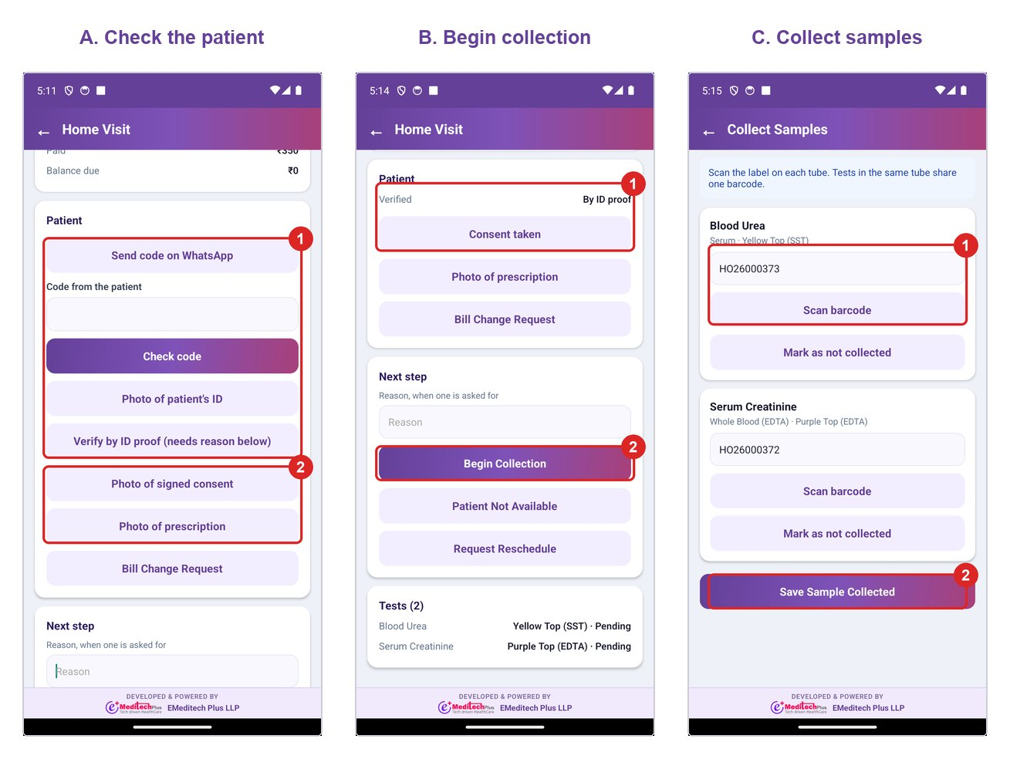
Figure 4. In A, (1) verify by WhatsApp code or ID proof, then (2) take the consent photo. In B, (1) shows both done, so tap (2) Begin Collection. In C, (1) each tube shows its barcode, already filled if a label was printed. Check it, or enter or scan it.
A tube marked as not collected creates a new visit for the next day, which the dispatcher can re-time.
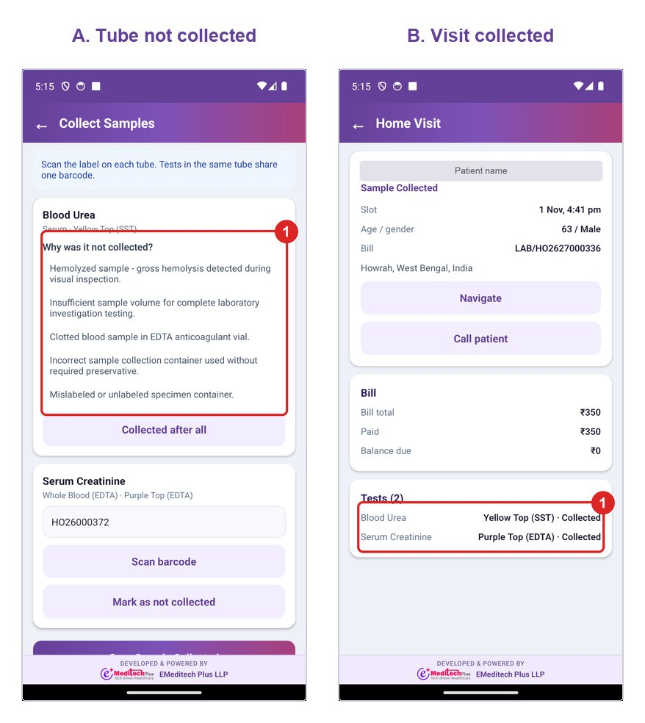
Figure 5. In A, (1) choose why the tube was not taken. In B, (1) the tests show Collected after you save.

Take payment
Take payment from the Bill card after you tap Reached.
- Choose CASH, UPI or CARD.
- Enter the amount. Leave it blank to take the full balance.
- For UPI or card, enter the reference number.
- Tap Record Payment and note the receipt number.
If money stays due, the app asks why before it saves the collection. Partner bills show Partner bill and you take no payment.
An unpaid bill does not stop collection. Take the payment first if you can. If the patient cannot pay, type why in the box on Collect Samples, and the balance stays on the bill for the office to follow up.

Change the bill
Raise a change after Reached and before samples are saved. Tap Bill Change Request.
- Choose Add test, Remove test, Discount or waiver, Payment mode or Patient details.
- Pick the tests, or type what should change.
- Enter the Reason and tap Send Request.
What happens next depends on Bill Change Approval Required in Hospital Settings. When it is on, the bill does not change until the office approves the request. You cannot save samples while a request is waiting, so call the office if it takes long. When it is off, a test change updates the bill straight away, and the app shows the new total and balance due. A discount still waits for the office either way. After a test change, reopen the visit: added tests appear under Tests, and the balance due is updated for you to collect.
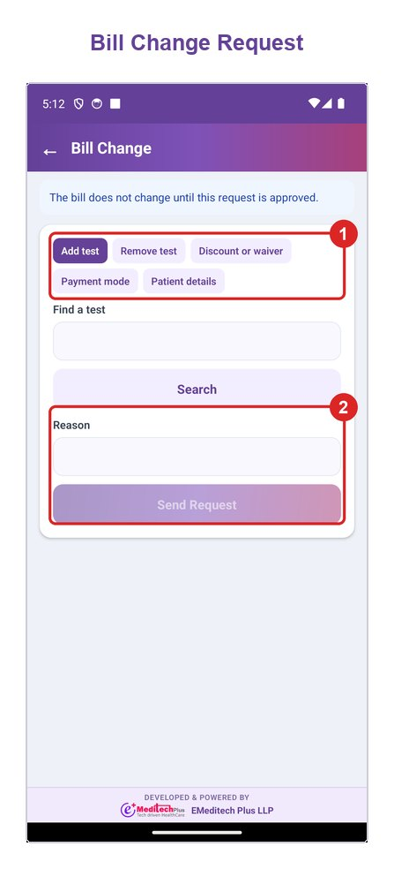
Figure 6. (1) Choose the type of change. (2) Enter the reason and tap Send Request.

When the visit cannot be done
- Type the reason in Next step.
- Tap Patient Not Available, or Request Reschedule if the patient asks for another time.
- The visit then appears under Needs action on the Dispatch screen.

Hand over samples
- Reach the lab and tap Hand Over Samples.
- Keep the visits you are handing over selected.
- Enter Received by and Box temperature.
- Tap Submit Manifest and note the manifest number.
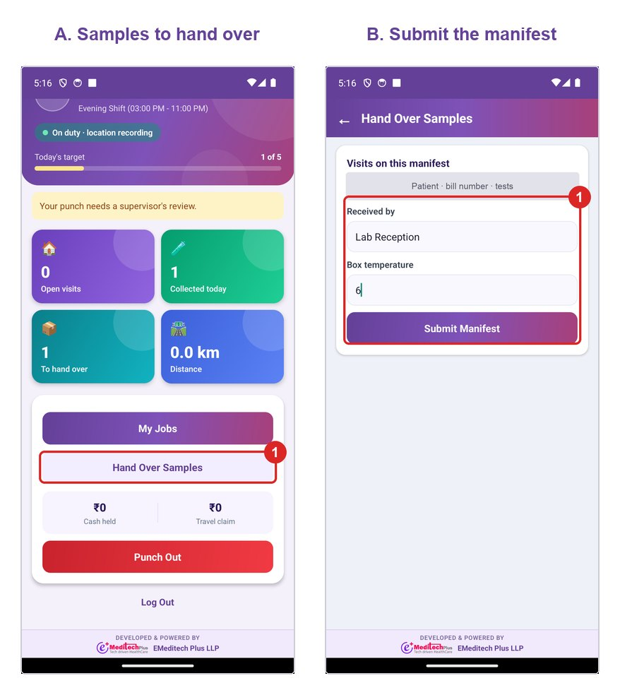
Figure 7. In A, tap (1) Hand Over Samples. In B, (1) enter who received the samples and the box temperature, then tap Submit Manifest.

Punch out
Tap Punch Out at the end of the day. It works only after your running visit is finished and all collected samples are handed over. Log Out only signs you out, so punch out first.

No signal
Visit steps save on the phone and send when signal returns. The dashboard shows how many are waiting. Punching, photos, payment and saving samples need signal.

Web app
The bill page gives the visit its first phlebotomist, and the Dispatch screen handles everything after the bill is saved.

Book the home collection
- Open the B2C or B2B lab booking page.
- Set Collection Type to Home Collection.
- Enter the home collection address. Country and State become mandatory.
- Choose the Phlebotomist and the booking date and time.
- Add the tests and the home collection charge from misc charges.
- Save the bill.
The visit reaches the Dispatch screen and the phlebotomist's app on their next refresh. No separate step is needed.
Save & Book opens Collect Payment. Choose the payment mode, enter the amount and tap Collect. If the patient will pay at home, tap Pay later (save as due). The phlebotomist then sees the balance due in the app.
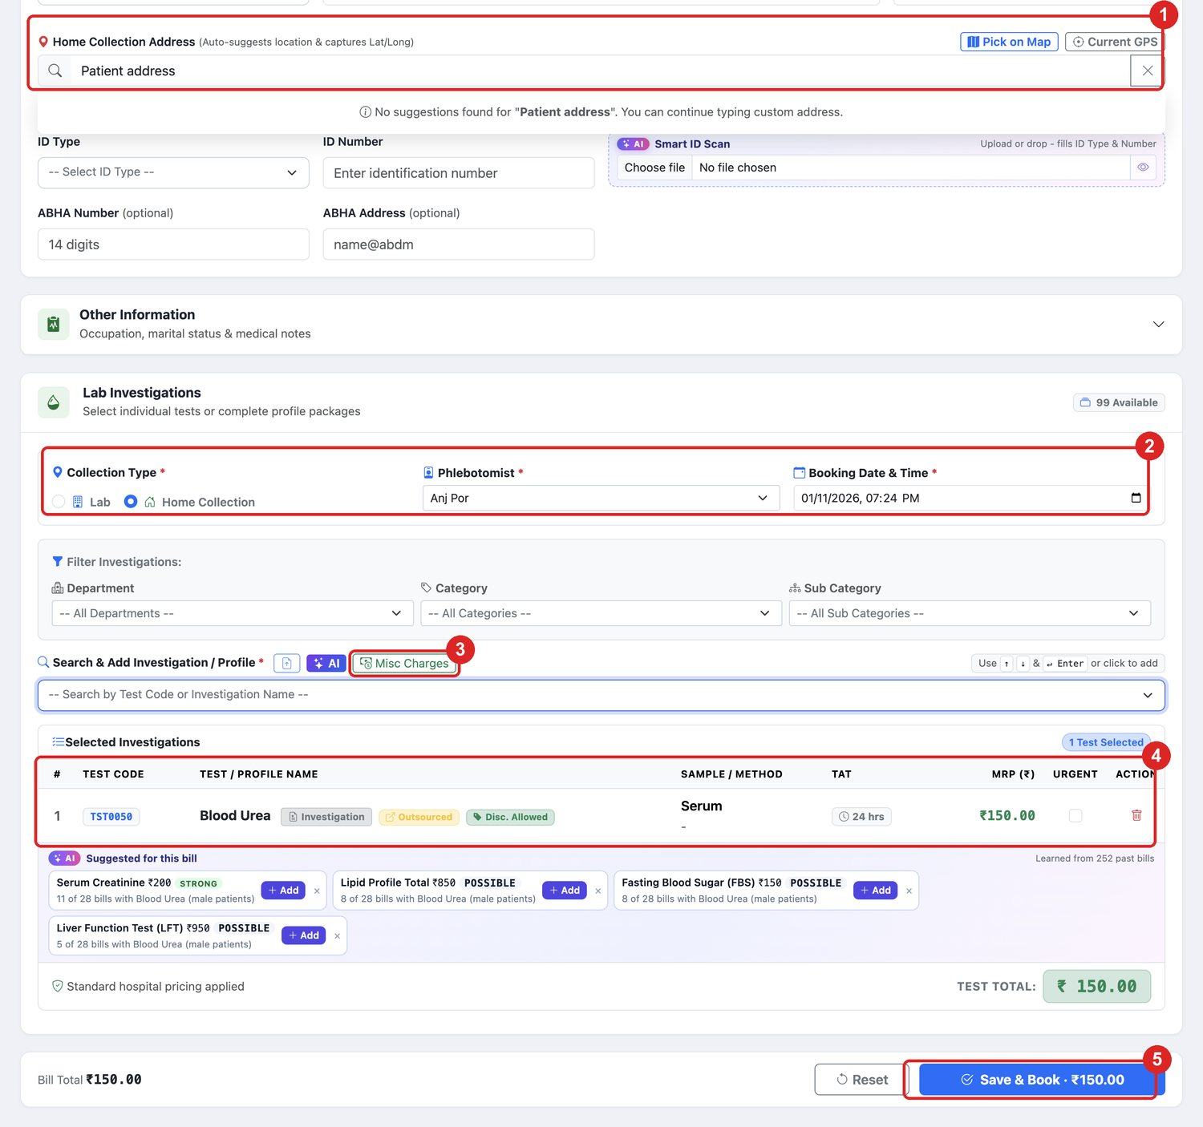
Figure W5. On the bill, enter (1) the Home Collection Address, (2) set Collection Type to Home Collection and choose the Phlebotomist and Booking Date & Time, (3) add charges from Misc Charges, (4) check the tests, then tap (5) Save & Book. This is a sample bill that was not saved.
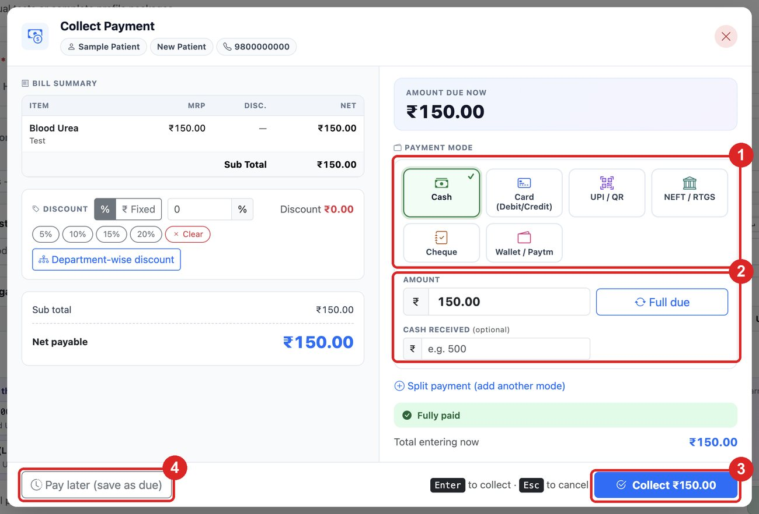
Figure W6. Choose (1) the payment mode, enter (2) the amount and tap (3) Collect. To leave the amount for the home visit, tap (4) Pay later (save as due). This is a sample bill that was not saved.

When to use the Bill page and the Dispatch screen
 | Bill page | Dispatch screen
First assignment | Yes | Not needed
Change phlebotomist after saving | No | Yes
See who is on duty and how busy they are | No | Yes
See Patient Unavailable and reschedule requests from the phone | No | Yes
Set a new visit slot | No | Yes
Close a visit without cancelling the bill | No | Yes
See all visits and their live status together | No | Yes

Read the Dispatch screen
Open LAB > Home Collection Dispatch. Set Date, or search by patient, mobile or lab booking number, then tap Show. The tiles filter the list.
Tile | Visits shown | What the dispatcher does
Needs action | Patient unavailable or reschedule requested | Reschedule, reassign or close. Check this first
Not started | Assigned or accepted | Reassign if needed. Late visits are marked
In the field | On the way, reached or collecting | Monitor
Collected | Collected or handed over | No action
All visits | Everything in the list | Overview
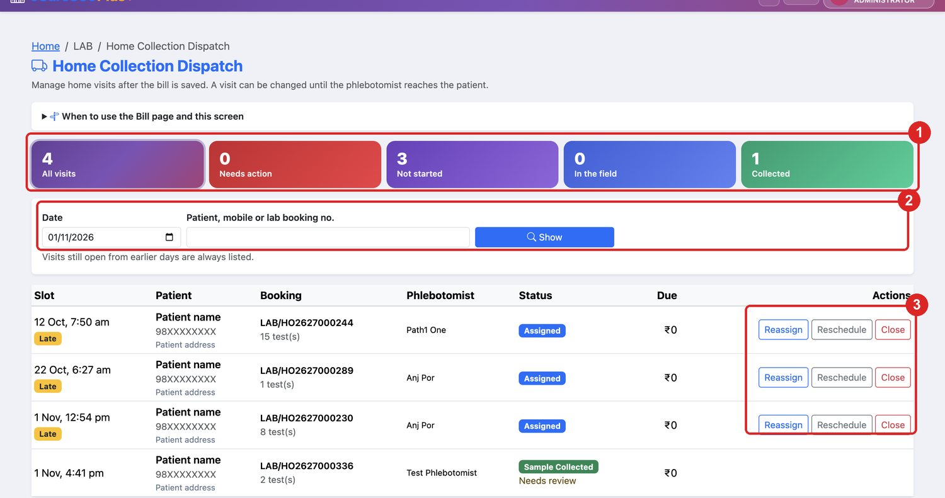
Figure W7. On the Dispatch screen, (1) tap a tile to filter the list, (2) set the date or search, and (3) use the buttons on a visit. A visit that has been collected shows no buttons. Patient details are hidden in this picture.

Act on a visit
Every action needs a reason, which is saved in the visit history.
Button | Use it when | Steps
Reassign | Another phlebotomist should go | Choose the name, enter the reason, save. The list shows who is on duty and their open visits
Reschedule | The time changes | Choose New slot, optionally change the phlebotomist, enter the reason, save
Close | The visit will not happen | Enter the reason and save. The bill stays
Reopen | A closed visit is needed again | Choose a new slot, enter the reason, save
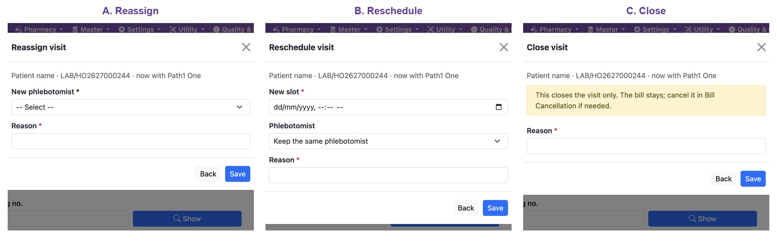
Figure W8. A shows Reassign, B shows Reschedule and C shows Close. Each one needs a Reason before you tap Save. Patient details are hidden in this picture.
To cancel the bill as well, use Bill Cancellation. The visit then shows as cancelled by itself.
A reassign or reschedule makes the new visit start again, so the patient check and consent are repeated. No change is possible after the phlebotomist taps Reached, except for a visit later marked unavailable or reschedule requested.

Approve a bill change
Open LAB > Bill Change Approval. Decide requests quickly, because the phlebotomist is waiting at the patient's address and cannot save samples until you do. The list refreshes by itself.
Request | When you tap Approve
Add test | The test is added at its rate, with its sample and barcode. The bill total and balance due go up
Remove test | The test is cancelled from the bill as a partial cancellation. If the patient has overpaid, the message gives the amount to refund from Bill Cancellation
Discount or waiver | Enter the amount, up to the balance due. The bill total and balance due go down
Payment mode, Patient details | The decision is recorded only. Make the change on its usual screen
Tap Refuse and enter a reason to leave the bill as it is. The phlebotomist sees the result under Requests on this visit. Test changes can be approved only while the phlebotomist is at the patient's address.
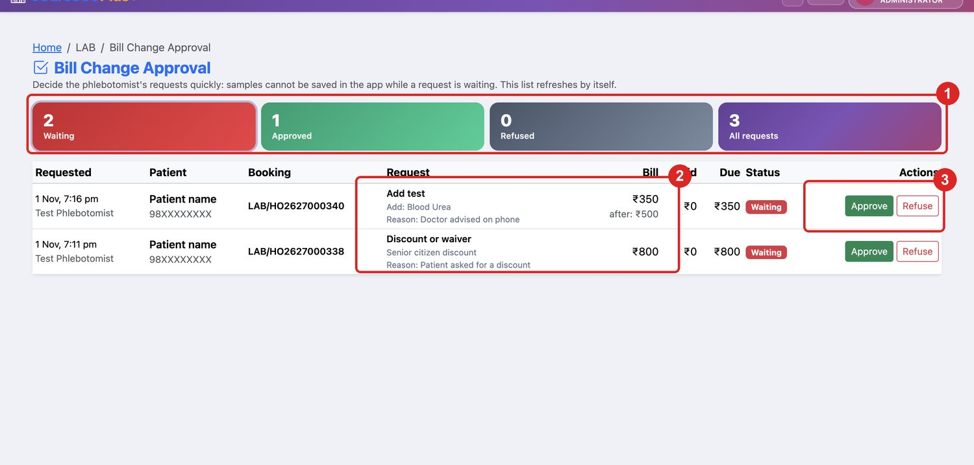
Figure W9. (1) Waiting shows the requests to decide. (2) Each row shows what was asked and why. (3) Tap Approve or Refuse. The rows in this picture are examples made for this manual, not real requests.
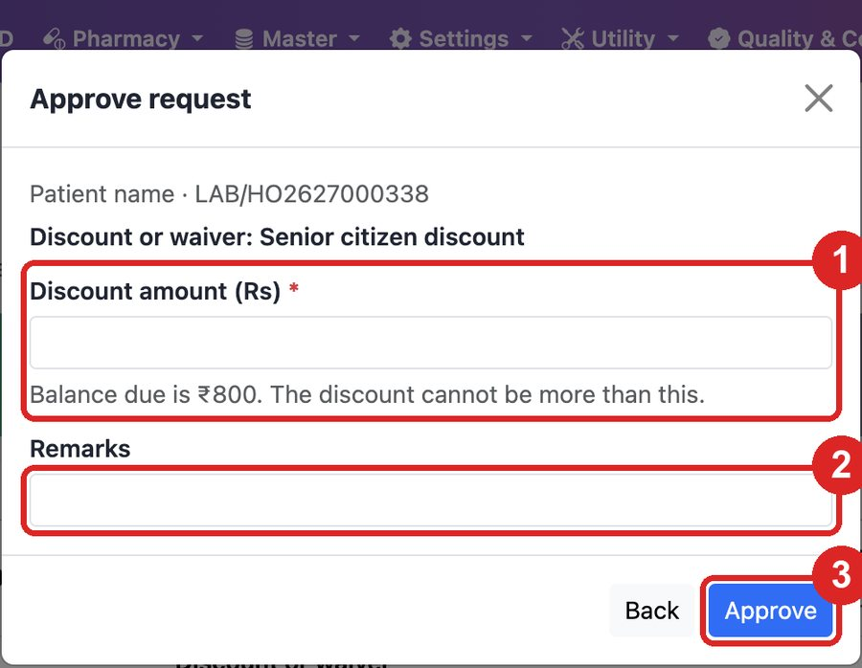
Figure W10. For a discount, enter (1) the amount, add (2) any remarks and tap (3) Approve. The rows behind this window are examples.

Turn approval on or off
Open Settings > Hospital Settings, tap Edit, open the LAB tab and set Bill Change Approval Required. It is on by default and applies to all branches of the company.
Request | Approval on | Approval off
Add test, Remove test | Waits for the office | Applied to the bill straight away
Payment mode, Patient details | Waits for the office | Recorded as approved at once; the office still makes the change on its usual screen
Discount or waiver | Waits for the office | Waits for the office, because the app sends no amount
With approval off, automatic decisions still appear on LAB > Bill Change Approval under Approved, marked "Automatic: approval is off in Hospital Settings." If a removed test leaves the patient overpaid, the app tells the phlebotomist to ask the office to refund the amount from Bill Cancellation. Requests already waiting when you turn approval off stay on the page until someone decides them.

Approve a phlebotomist's phone
Open LAB > Phlebotomist Phones. Waiting lists the phones that cannot be used yet, with the phlebotomist, the phone's make and model, and when it was first and last seen.
- Approve lets the phone work. Block this user's other phones is ticked by default, so only one phone stays in use. Untick it to keep the others.
- Block stops a phone, for example a lost one. A blocked phone can be approved again later.
The phlebotomist reopens the app after approval. Phones registered before this screen existed show as "Phlebotomist phone", without the make and model.

After handover
Samples saved in the app already show as collected in Sample Collection Management, with their barcodes. The lab continues from there on its usual screens.

Reports
These existing reports under Reports > LAB cover home collection, but none is yet dedicated to phlebotomist attendance, travel, cash or handover.
Report | Use it for | Useful filter
Samples Pending Collection | Home samples still waiting, by wait time and phlebotomist | Collection type, Phlebotomist
Sample Rejection & Re-collection | Samples rejected or sent for re-collection | Outcome, Reason, Collected by
Daily Billing Register | Bills raised in the period | Billing type, Payment status
Outstanding Dues & Ageing | Amounts left due after a visit | Age bucket
Cashier Day-end Closing | Money collected, by payment mode and collector | Payment method, Collected by
Cancellation & Refund Register | Cancelled home bills and refunds | Cancellation type
Staff Productivity | Receipts taken and specimens collected per person | Activity, Staff
Work Pending by Stage | Samples at each lab stage | Stage, Wait band
Turnaround Time (TAT) | Time taken to report results | TAT status, Department
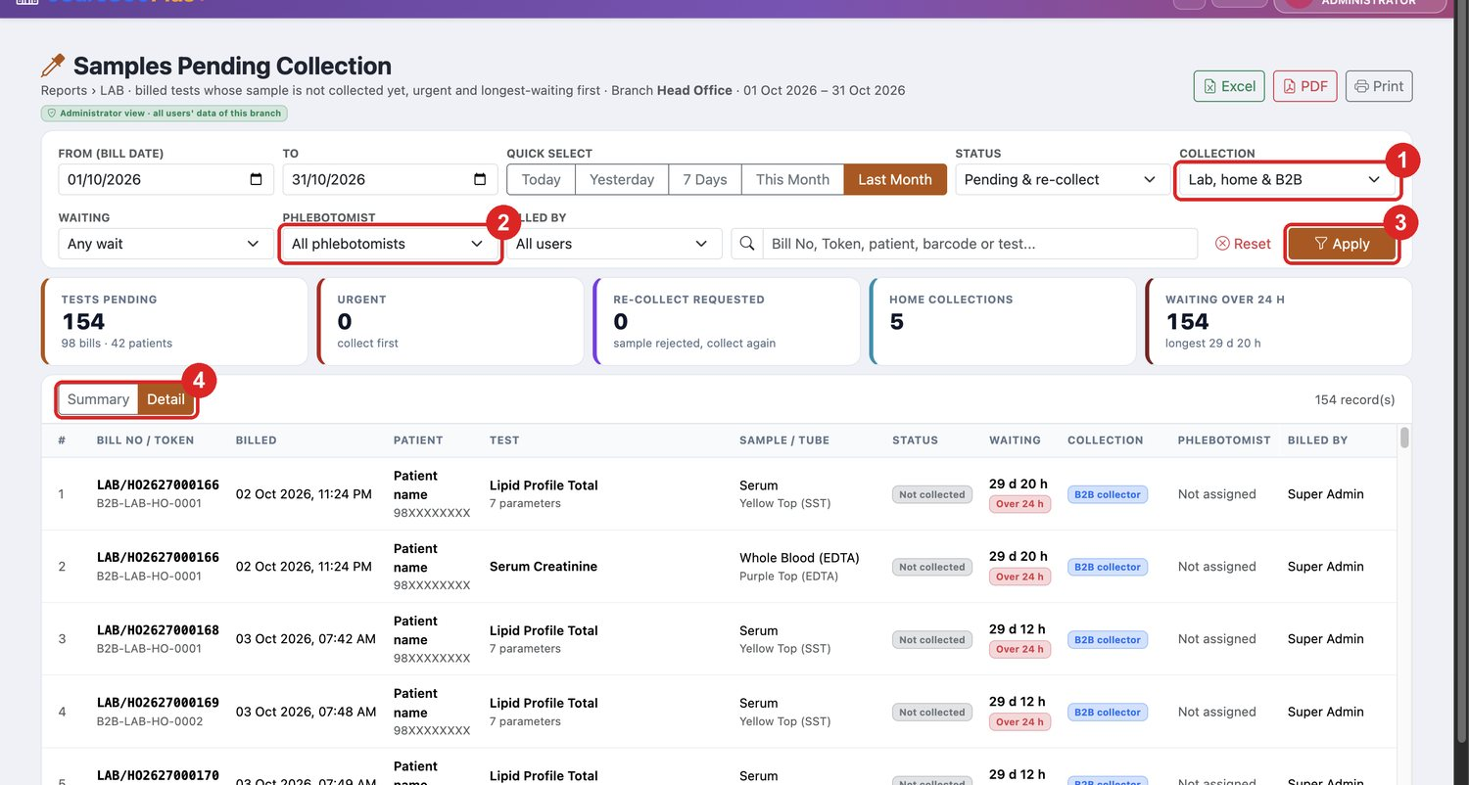
Figure W11. In Samples Pending Collection, set (1) Collection and (2) Phlebotomist, tap (3) Apply, and open (4) Detail for the list of samples. Patient details are hidden, and the figures are test data.
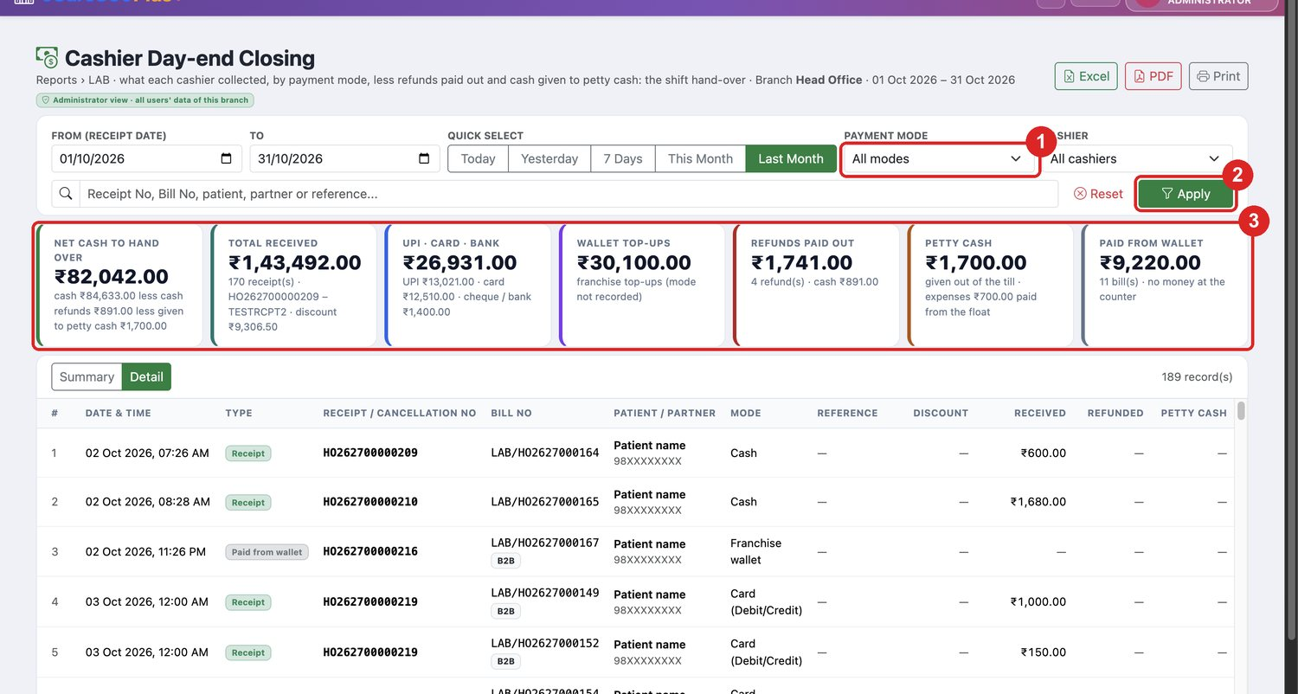
Figure W12. In Cashier Day-end Closing, set (1) Payment Mode, tap (2) Apply and read (3) the totals. Patient details are hidden, and the figures are test data.
Payments from the app are ordinary bill receipts with their own receipt number, marked with the note "Phlebotomist app". The Dispatch screen is the daily view of visits, while these reports are for checking afterwards.
The app records this data, but no web page shows it yet: attendance and punch photos, GPS route and kilometres, cash held, and handover manifests.

Visit statuses and rules
A visit can be changed from the office until the phlebotomist taps Reached.
Status | Meaning | Reassign | Reschedule | Close
Assigned / Accepted | Waiting to start | Yes | Yes | Yes
On the way | Phlebotomist travelling | Yes | Yes | Yes
Reached / In progress | At the patient | No | No | No
Patient unavailable | Phlebotomist could not collect | Yes | Yes | Yes
Reschedule requested | Patient asked for another time | Yes | Yes | Yes
Collected | Samples taken, not yet handed over | No | No | No
Handed over | Given to the lab | No | No | No
Closed | Ended from the Dispatch screen | No | Reopen | No
Cancelled | The booking was cancelled | No | No | No
The main rules, with the settings that are on by default:
- The phlebotomist must be punched in to work on any visit.
- Only one visit can be running at a time.
- Punch in beyond 200 m of the branch or start point is saved, then flagged for review.
- Reached beyond 200 m of the patient's pin needs a reason, and the visit is flagged for review.
- A punch in more than 15 minutes after shift start is marked late.
- Consent and patient verification come before collection.
- An amount left due needs a reason.
- A barcode already used on another booking is refused.

Problems and fixes
Most messages in the app state the next step, so follow the message first.
Message or problem | What to do
Your shift or zone is not set | Administrator sets Shift and Assigned Zone in Users
This login is not set up as a phlebotomist | Administrator turns on the Phlebotomist switch
This phone is waiting for your supervisor's approval | Approve it on LAB > Phlebotomist Phones. Do not install the app again, as that adds another phone
Take these photos first | Finish the Duty checklist
Your location is needed to punch | Turn on GPS and allow location
Punch in before you start a visit | Punch in from the dashboard
Finish your open visit before you start another | Finish the running visit, or mark it unavailable
Finish your open visit before you punch out | Complete the running visit first
Hand over your collected samples before you punch out | Submit the manifest first
You have already punched in today | Only one punch in is allowed per day
Amount cannot exceed the balance | Enter an amount up to the Balance due
This bill has no payment record yet | Ask the branch to open the bill
No visit shown in the app | Check the visit on the Dispatch screen, then pull down to refresh

Not available yet
- Lab receipt of the manifest. The handover records the receiver's typed name only. The lab does not confirm it on screen.
- Cash deposit. The app tracks cash held, but no screen records the deposit.
- Duty roster. The system has shifts, but no daily roster of who works which day.
- Settings screen. Radius, photos, OTP and rate per km can be changed only in the database.
- Release app. The server at 103.178.113.61:9011 must have the latest EMR.Api before the release app can connect.

Not yet tested end to end
Barcode scanning, WhatsApp OTP, Record Payment, saving Reschedule or Close from the web, and a bill change from the app, with approval on and off. Test these before go-live.

